**PROJECT NAME: regmysqlpro category:student registrationform**

**Database name: Mysql**

**Username: regmysql**

**Password:1234**

**For open user login and user admin**

**Username: shankar**

**Password:1234**

1. **Create project(folder) name as regmysqlpro by cmd(venv)**
2. **Create project app(folder) as regapp**
3. **Open file by VScode**
4. **Goto settings.py in project folder**
5. **Import ‘os’**
6. **Add ‘regapp’ in under installation list**

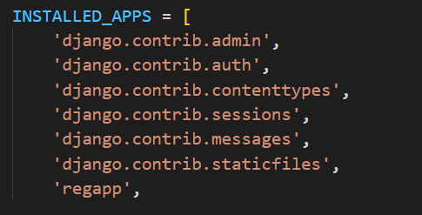

**7.create BASE_DIR in settings.py file**

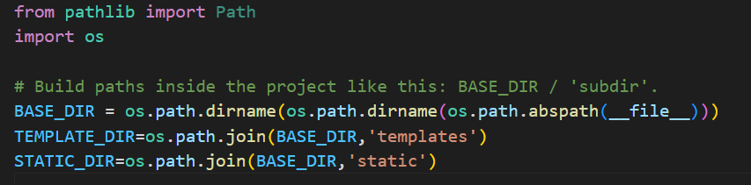

**8.add template source in templatebox in settings.py**

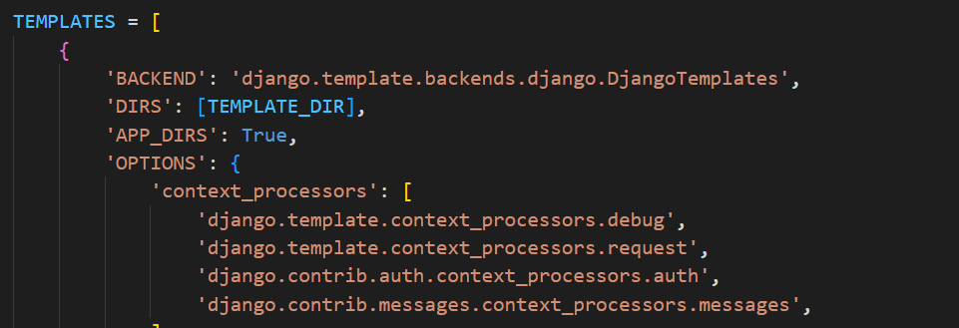

**9.add database Mysql in settings.py file at database place**

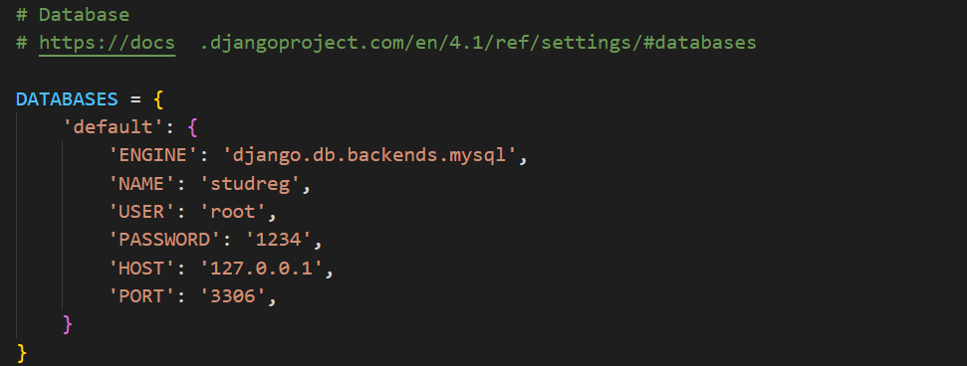

**10.add static files in settings.py file**

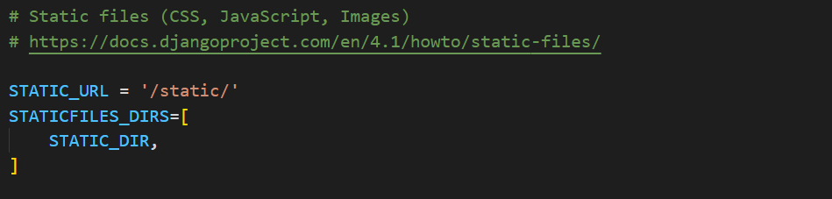

**11.lets come back to vscode and create template folder in project folder ‘regmysqlpro’**

**12.again create a subfolder under template as ‘regapp’ folder**

**13.in this folder create all html files what we required.**

**14.now create home.html file first**

**15.open view.py file in regapp folder and define a function as ‘home’ and import the things from django like below**

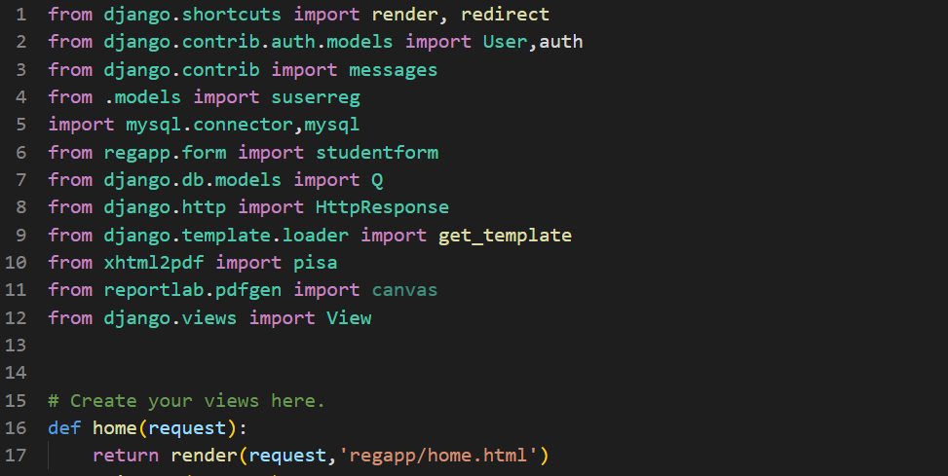

**16.lets come to url.py file in project folder and create urls for homepage and import the view from regapp**

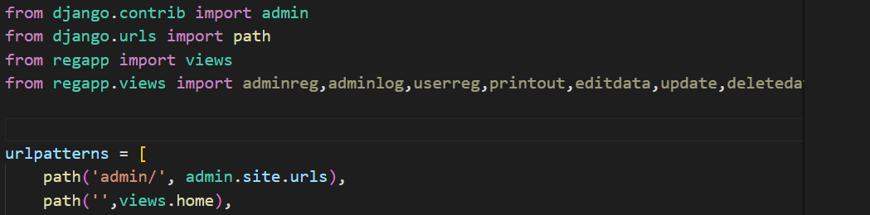

**17.now lets come to vscode and run the server**

**18. in terminal panel type ‘py manage.py runserver’ and enter**

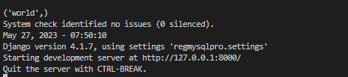

**19. press cntl button + click that link ‘http://127.0.0.1:8000/’**

**20. now output homepage .**



**21.simillarly we can create remaining pages and we can write respective view functions with appropreite url**

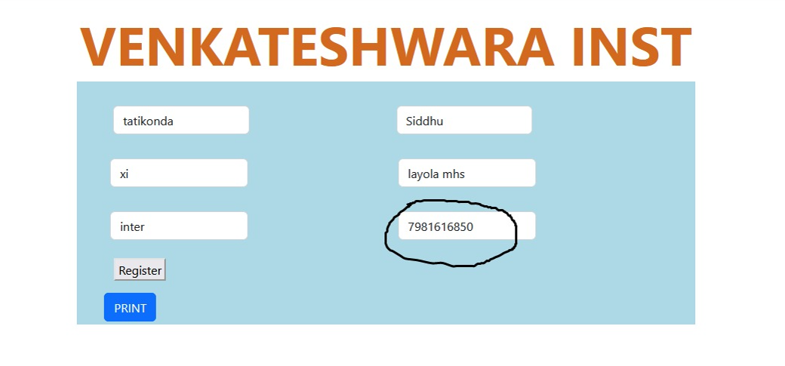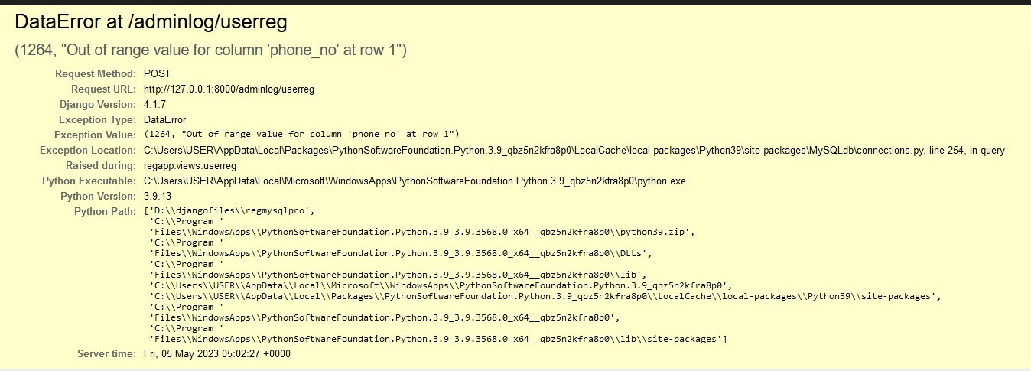

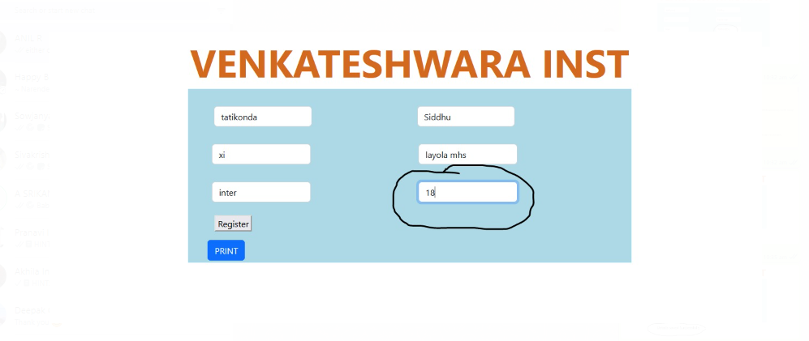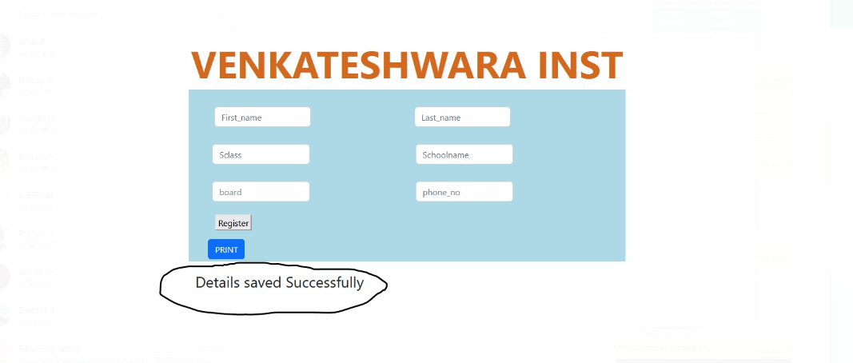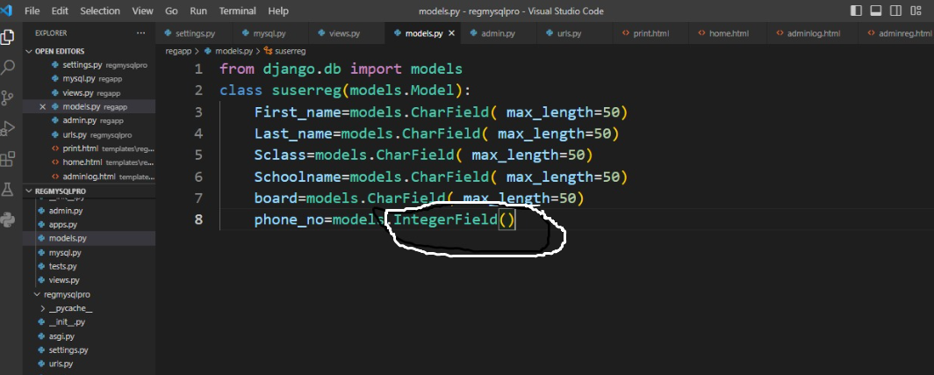

**Then change it integerfield into charfield**

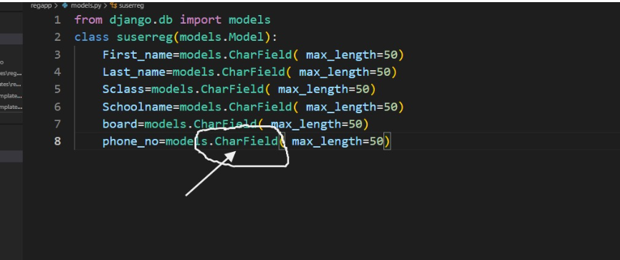

**Now entering 10 digit number**

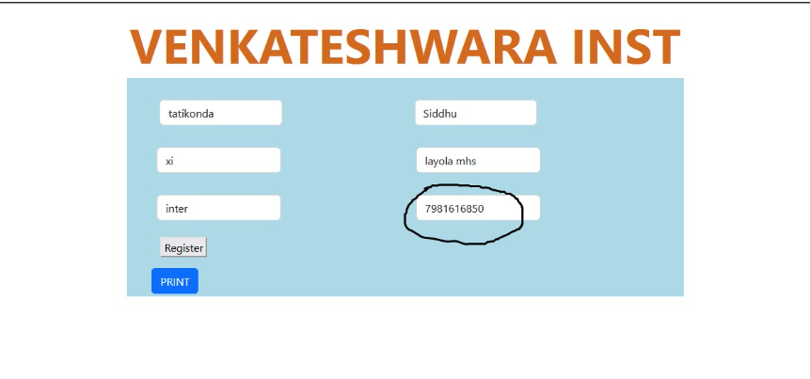

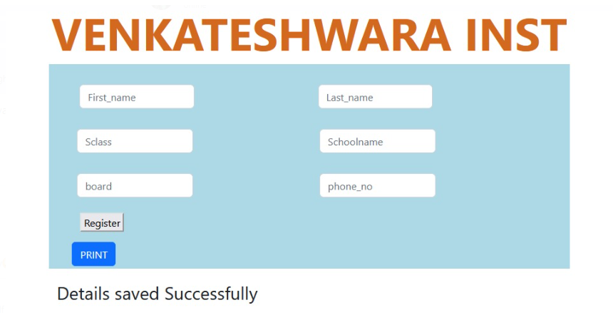

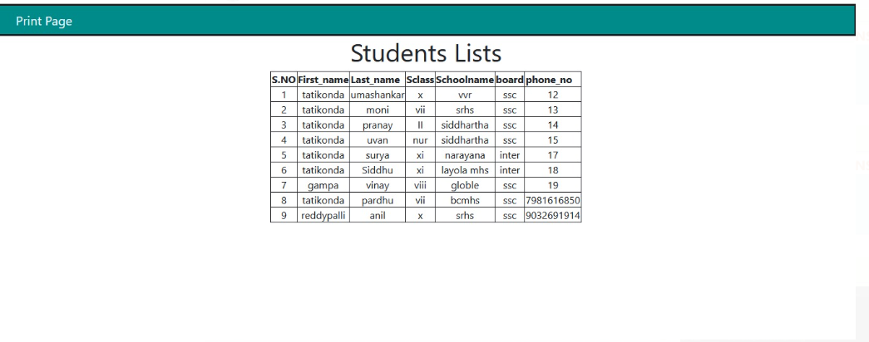

**Next edit ,update and delete**